Dressing Change Kits

Sterile dressing change kits may help to reduce the risk of CLABSI, and to ensure you have all the supplies you need.

Sterile dressing change kit:

* Chlorhexidine scrub 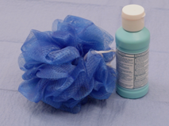
* Sterile gloves 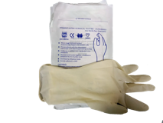
* Chlorhexidine-containing sponge (if using) 
  + Transparent dressing if you are using a chlorhexidine-containing sponge
* Chlorhexidine-containing transparent dressing if you are not using a chlorhexidine-containing sponge
* Tape for label 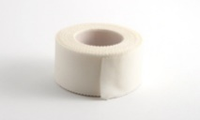

Outside of the sterile dressing kit:

* Soap and water or hand sanitizer 
* Non-sterile gloves separate from the sterile dressing change kit. 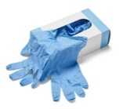
* Marker or pen to label dressing Black marker
  
* Clean, flat surface on which to place the sterile dressing change kit and sterile gloves.
* Alcohol wipes or saline wipes 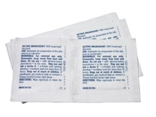 to remove any debris or dried material on the line.